- Purpose:

The purpose of this policy is to describe how to properly label any chemicals that are found in and around the facility. This policy will help to protect the safety and health of our employee’s through simple and effective labeling requirements as well as helping to ensure this facility’s compliance with 29 CFR 1910.1200 for the labeling of hazardous chemicals.

- Scope:

OSHA has adopted new hazardous chemical labeling requirements as a part of its recent revision of the Hazard Communication Standard, 29 CFR 1910.1200 (HCS), bringing it into alignment with the United Nations’ Globally Harmonized System of Classification and Labeling of Chemicals (GHS). These changes will help ensure improved quality and consistency in the classification and labeling of all chemicals, and will also enhance employee comprehension.

This policy will cover the labeling requirements for both hazardous chemicals (i.e. Sulfuric Acid) and non-hazardous chemicals (i.e. Magnesium Sulfate, dilute cleaning solutions, etc.)

- Responsibility:

It is the responsibility of the Safety Department to ensure that all chemicals and chemical storage areas are clearly and correctly labeled.

Each employee is responsible for notifying the Safety Department of any damaged, missing, obscured, or incorrect labels.

- Safety Considerations:

Safety is a condition of employment. Employees are not authorized to work in an unsafe manner and are prohibited from harming the environment of the facility or community.

- Materials/Equipment:

N/A

- Procedure:

All labels whether hazardous or not will have minimum label requirements. These requirements are in place to aid in easy and quick identification, to prevent accidental misuse, inadvertent mixing of incompatible chemicals, and ensure proper safety measures are taken if an incident should occur. Specific labeling requirements will vary with the type of container and the hazard level of the chemical. Any media (i.e. sticker, tape, sharpie, pen, etc.) can be used to label a container as long as it is resistant to smearing and fading. Old labels must be completely defaced or removed when reusing containers unless the old label accurately describes the new contents.

- All Chemical Types

Label Requirements:

There are 3 types of container classifications in which chemicals are stored or found. These three types are Permanent Containers, Durable Containers, and Transient Containers. Each of these 3 types of containers have their own labeling requirements.

• Primary Containers – those containers as received from the manufacturer (i.e. food-grade grease, container of bleach, dawn dish soap, etc.). Permanent containers must be labeled with the following information: chemical name or constituents and manufacturer name and address/contact information. Whenever possible, Permanent Containers should be labeled with the date of receipt. Note: if the contents are Hazardous then the labels must also adhere to the requirements contained within the hazardous chemical section.

• Secondary Containers – are containers that are not provided by the manufacturer but which hold chemicals that will be used in only one work area, usually for longer than one day and by more than one person (i.e. spray bottles, buffer solutions, dilute cleaning solutions, IPA in a spray bottle, etc.). All Durable Container labels should contain the following: name of contents; concentration (either in % or as a ratio); date of preparation; and preparer’s initials. Note: if the contents are Hazardous then the labels must also adhere to the requirements contained within the hazardous chemical section.

• Temporary Containers - are containers that will be used to hold chemicals for one work shift or less and will be under the direct control of the person filling the container (i.e. beakers, TLC salt test tubes, TLC Mobile Phase, Brine Graduated Cylinder’s, etc.). No labeling is required for this kind of container until they are no longer under the control of the person who prepared the material (i.e. leaving for lunch or at the end of your shift). It is best practice to label Transient Containers in accordance with the Durable Container requirements to avoid any misuse or inadvertent mix-ups.

Bleach Water 1:10 (10%)
Prepared By: John Smith
Date: 9/29/2015
Example of an appropriate label

- Hazardous Chemicals ONLY

Label Requirements:

Labels, as defined in the HCS, are an appropriate group of written, printed or graphic informational elements concerning a hazardous chemical that are affixed to, printed on, or attached to the immediate container of a hazardous chemical, or to the outside packaging.

The HCS requires chemical manufacturers, importers, or distributors to ensure that each container of hazardous chemicals leaving the workplace is labeled, tagged or marked with the following information: product identifier; signal word; hazard statement(s); precautionary 1 2 statement(s); and pictogram(s); and name, address and telephone number of the chemical manufacturer, importer, or other responsible party.

Labels must be legible, in English, and prominently displayed. Other languages may be displayed in addition to English. Chemical manufacturers, importers, and distributors who become newly aware of any significant information regarding the hazards of a chemical must revise the label within six months.

Definitions:

• Product Identifier - is how the hazardous chemical is identified. This can be (but is not limited to) the chemical name, code number or batch number. The manufacturer, importer or distributor can decide the appropriate product identifier. The same product identifier must be both on the label and in section 1 of the SDS.

• Signal Words - are used to indicate the relative level of severity of the hazard and alert the reader to a potential hazard on the label. There are only two words used as signal words, “Danger” and “Warning.” Within a specific hazard class, “Danger” is used for the more severe hazards and “Warning” is used for the less severe hazards. There will only be one signal word on the label no matter how many hazards a chemical may have. If one of the hazards warrants a “Danger” signal word and another warrants the signal word “Warning,” then only “Danger” should appear on the label.

• Hazard Statements - describe the nature of the hazard(s) of a chemical, including, where appropriate, the degree of hazard (i.e. “Causes damage to kidneys through prolonged or repeated exposure when absorbed through the skin.”) All of the applicable hazard statements must appear on the label. Hazard statements may be combined where appropriate to reduce redundancies and improve readability. The hazard statements are specific to the hazard classification categories, and chemical users should always see the same statement for the same hazards no matter what the chemical is or who produces it.

• Precautionary Statements - describe recommended measures that should be taken to minimize or prevent adverse effects resulting from exposure to the hazardous chemical or improper storage or handling. There are four types of precautionary statements: prevention (to minimize exposure); response (in case of accidental spillage or exposure emergency response, and first-aid); storage; and disposal (i.e. a chemical presenting a specific target organ toxicity hazard would include the following on the label: “Do not breathe dust/fume/gas/mist/ vapors/spray. Get medical attention if you feel unwell. Dispose of contents/ container in accordance with local/regional/ national and international regulations.”) A forward slash (/) designates that the classifier can choose one of the precautionary statements.

• Pictograms - are graphic symbols used to communicate specific information about the hazards of a chemical. On hazardous chemicals being shipped or transported from a manufacturer, importer or distributor, the required pictograms consist of a red square frame set at a point with a black hazard symbol on a white background, sufficiently wide to be clearly visible. A square red frame set at a point without a hazard symbol is not a pictogram and is not permitted on the label. The pictograms OSHA has adopted improve worker safety and health, conform with the GHS, and are used worldwide. While the GHS uses a total of nine pictograms, OSHA will only enforce the use of eight. The environmental pictogram is not mandatory but may be used to provide additional information. Figure 1 shows the symbol for each pictogram, the written name for each pictogram, and the hazards associated with each of the pictograms.

Note: OSHA pictograms do not replace the diamond-shaped labels that the U.S. Department of Transportation (DOT) requires for the transport of chemicals, including chemical drums, chemical totes, tanks or other containers.

Health Hazard  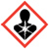  - Carcinogen  - Mutagenicity  - Reproductive Toxicity  - Respiratory Sensitizer  - Target Organ Toxicity  - Aspiration Toxicity | Flame  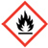  - Flammables  - Pyrophorics  - Self-Heating  - Emits Flammable Gas  - Self-Reactives  - Organic Peroxides | Exclamation Mark  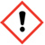  - Irritant (skin and eye)  - Skin Sensitizer  - Acute Toxicity  - Narcotic Effects  - Respiratory Tract Irritant  - Hazardous to Ozone Layer (Non-Mandatory)
Gas Cylinder  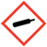  - Gases Under Pressure | Corrosion  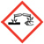  - Skin Corrosion/Burns  - Eye Damage  - Corrosive to Metals | Exploding Bomb  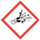  - Explosives  - Self-Reactives  - Organic Peroxides
Flame Over Circle  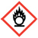  - Oxidizers | Environment  (Non-Mandatory)  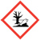  - Aquatic Toxicity | Skull and Crossbones  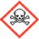  - Acute Toxicity (fatal or toxic)
Figure 1

An example of a proper hazard label is shown below (Figure 2) please note that this example is for informational purposes only and are not meant to represent the only labels manufacturers, importers and distributors may create for these hazards.

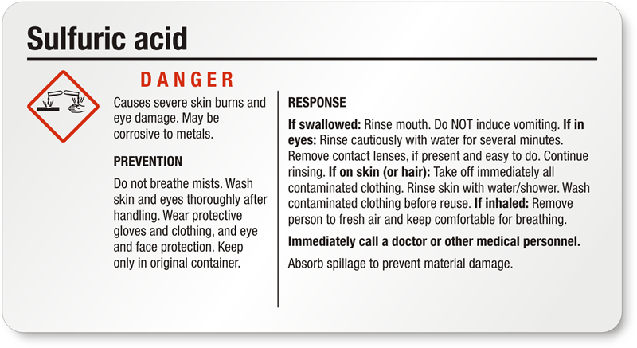
Figure 2

7.0 Reference Documents:

N/A

8.0 Change Information:

Complete Document Revision

